**Shell Scripting**

1. **Description- Script to print the following:**

• Currently logged users

• Your shell directory

• Home directory

• OS name & version

• Current working directory

• Number of users logged in

• Show all available shells in your system

• Hard disk information

• CPU information.

• Memory information.

• File system information.

• Currently running process

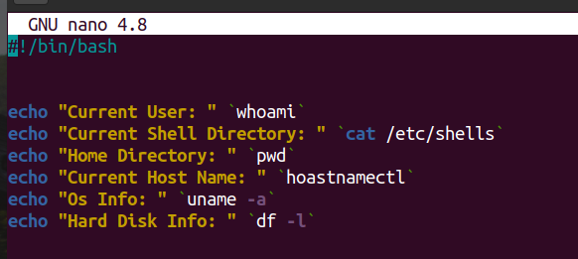

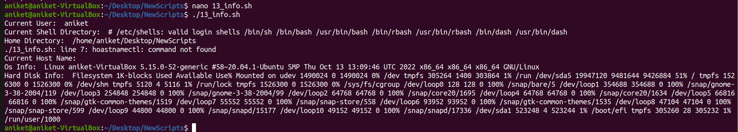

1. **Description- Script to rename a file/directory replaced by lower/upper case letters.**

Input- bash 14_file_upper_lower.sh

Output-Before running the script

ls

File.txt MyScript.SH MyFile007.txt dir/ Assign1/ newfolder/

After running the script

$ ls

file.txt myfile007.txt myscript.sh DIR/ ASSIGN1/ NEWFOLDER/

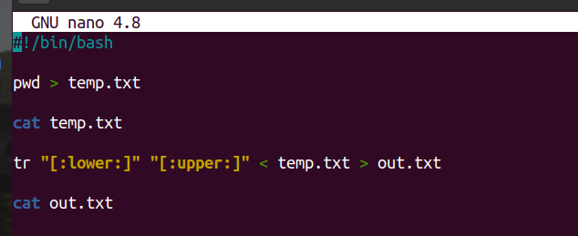



1. **Description- Script to rename the current working directory with a given name.**

Input- bash 15_rename_cur_dir.sh siddaling

Output- Before running the script:

Name of the current directory- siddaling1

After running the script:

Name of the current directory- siddaling

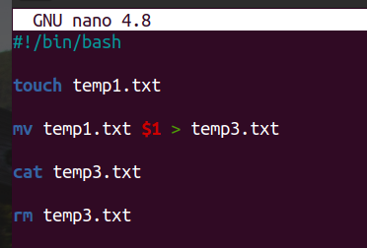

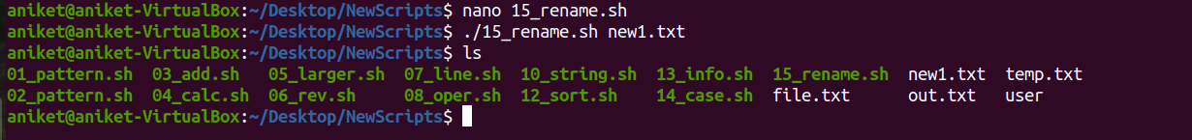

1. **Description- Script to print contents of a file from a given line number to the next given number of lines.**

Input- bash 17_print_lines.sh 5 4

Output- line 5

line 6

line 7

line 8

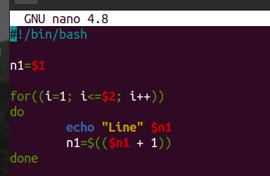

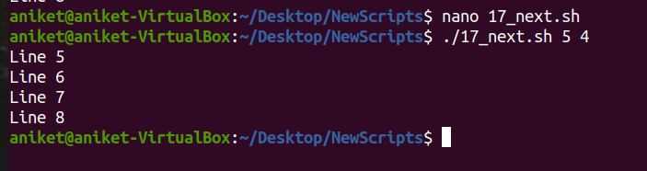

1. **Description- Script to convert content of file lower to uppercase and upper to lowercase.**

Input- bash 22_upper_lower.sh a.txt

1 – Lower to upper

2 – Upper to lower

please select the option: 1

Output- Before running the script:

Content of the file a.txt- Hello, I am Siddaling Kempasatti,

From Belgaum.

After Running script:

content of the file a.txt- HELLO, I AM SIDDALING KEMPASATTI,

FROM BELGAUM.

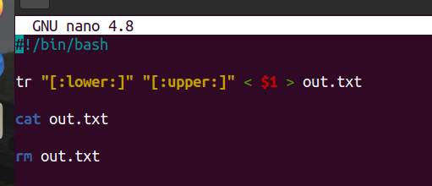

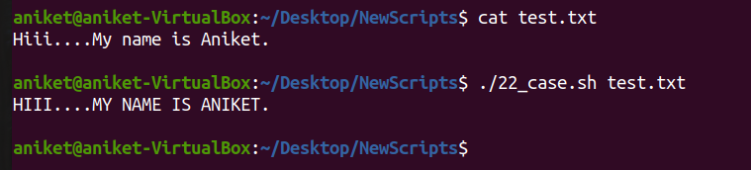

Description- Script to convert content of file lower to uppercase and upper to lowercase.

Input- bash 23_print_fifth_line.sh a.txt

Output- Before running the script:

Content of the file a.txt- Hello, I am Siddaling Kempasatti,

From Belgaum.

PESU, Bangalore.

Electronics and communication,

After Running script:

Output of the script- hELLO, i AM sIDDALING kEMPASATTI,

fROM, bELGAUM.

pesu, bANGALORE.

eLECTRONICS AND COMMUNICATION.





Description- Script to use pipes or redirection to create an infinite feedback loop.

Input- bash 24_redirection.sh

Output- Hello Siddaling

Hello Siddaling

Hello Siddaling

Hello Siddaling

Hello Siddaling

Hello Siddaling

Hello Siddaling

Hello Siddaling

Hello Siddaling

Hello Siddaling

Hello Siddaling

Hello Siddaling.................[infinity times]

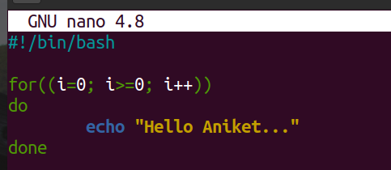

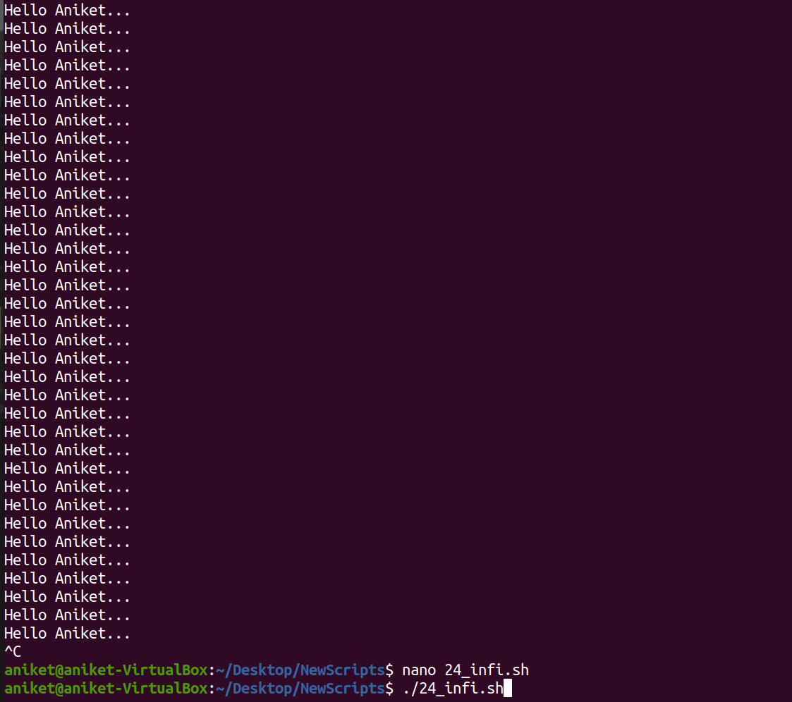

1. **Description- Script that takes any number of directories as command-line arguments and lists the contents of each directory.**

Input- bash 27_output_ls.sh siddaling Desktop

Output-

siddaling :

/home/siddaling/siddaling :

28_lock_permissions.sh a.c b.c test

/home/siddaling/siddaling/test :

a.txt b.txt c.txt d.txt Emertxe f.sh Siddaling z.sh

Desktop :

/home/siddaling/Desktop :

Emertxe

/home/siddaling/Desktop/Emertxe :

C Documents Linux Systems

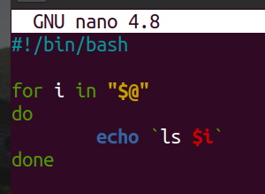

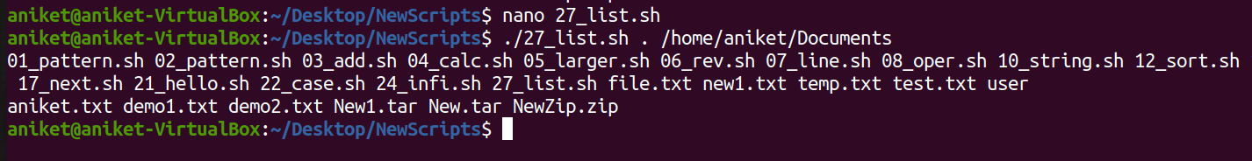

1. **Description-Script or each directory in the $PATH variable, to display the number of executable files in that directory.**

Input- bash 31_executable_path.sh

Output- Current dir: /usr/local/sbin

Current count: 0

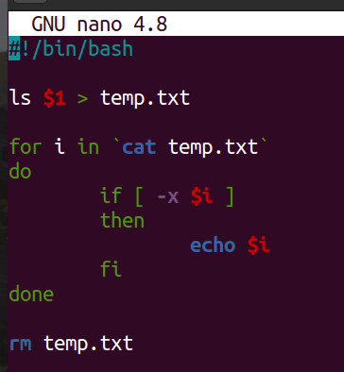

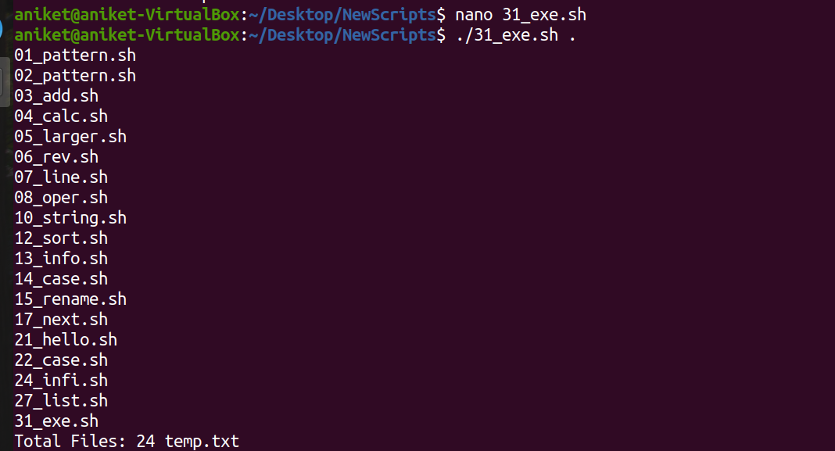

1. **Description- Script to calculate the BMI.**

Input- bash 34_BMI.sh

Enter the weight in Kg :48.2

Enter the height in meters :1.4

Output- The BMI is 25.3

You are overweight

